(Approx. 1123 words)

Traveling with Electronics
By Dick Maybach, Member, Brookdale Computer User Group, NJ
www.bcug.com
n2nd (at) att.net

When preparing for a trip, think carefully about what you really need. Every piece of gear you add is more weight to carry, another thing to protect, and another distraction from visiting and sightseeing. The goal should be to obtain the needed entertainment, communications, and navigation while minimizing your risk, inconvenience, and cost.

Begin by seeing what you can do with just a smart phone. If you are going overseas where roaming charges can be high, assume it’s configured not to make calls. You can still use it for communications by using a Web communication service, such as Skype, when you are at a Wi-Fi hotspot. Its music player and e-book reader can entertain you en route, provided of course that you load the media before you leave home. It will also let you read your e-mail and surf the Web, although its small screen makes these less efficient than using a PC. You can also install apps to track your credit and debit card expenses, safeguard your passwords, and calculate currency conversions. Most cell phones include a GPS, but by default they continually download maps from the network. If you want to use this feature where you don’t have cell-phone service, you must first download and install maps into your mapping app, such as Locus Map for Android. (Be aware that mapping apps can be complex and configuring them may require some work; start this well before you leave.) Finally, it has a camera to save your memories. Of course, you must install and configure the needed apps and become comfortable with them before you leave home. Expect to spend considerable time to get this right.

Thus, with a properly configured smart phone you can send and receive messages, access the Internet, navigate, secure your sensitive data, and take photos. However, you may decide that you want additional equipment to escape the phone’s limitations and are willing to accept the additional baggage, the extra delays at security checks, the added effort to safeguard the equipment, and the financial risk of losing it.

Small and light laptops are not expensive but try to make yours do jobs besides the obvious e-mail and Web surfing. For example, you can upload data from your camera, cell phone, and GPS, so that you retain the data if one is lost or damaged. You can also use its USB ports to charge your other devices and so avoid having to carry separate power converters. However, this will take more time than using a charger; check before you leave home.

If your hotel has wired Ethernet in the room you can use a travel router to provide better service than Wi-Fi___33. Some hotels limit the number of devices you can connect to their Wi-Fi___33 or charge separately for each one. If you connect your devices to Wi-Fi___33 through a travel router, shown in Figure 1, configured as a repeater, that is the only device registered, regardless of how many devices connect through it. See my article on travel routers in the November 2014 Bytes, available at http://www.bcug.com/.

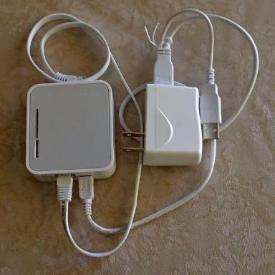
Figure 1. Travel Router.

A pocket GPS with extra replaceable batteries will help you find your way longer than a smart phone and may provide more features and offer more choice of maps. (Use it before you leave so you can find how long it will operate on a set of batteries.) Many free maps of areas all over the world are available, although most require that your device use Garmin-compatible map files. The same files are usable by PC mapping applications when you are at home.

If you are fond of reading, those e-book readers that display only black-and-white print have very long battery lives, making them practical even on long trips, and they often weigh less than a couple of books. However, those that display in color and play movies have battery lives comparable to small laptops. Be careful of media encumbered with Digital Rights Management (DRM) as this “feature” may not allow you to access it outside the U.S.

Think seriously about power. Your hotel room will probably have few outlets, likely in inconvenient locations, they may not fit U.S. plugs, and outside the Americas are likely to carry 220-Volt, 50-Hz power. Light-weight, ten-foot, two-wire extension cords with three outlets are widely available. (Three-wire cords are far too heavy to practical on trips, and few foreign outlets have three-wire connectors.) In many countries you will need a mechanical adapter to the local outlets; research this before you leave home. Take spare adapters; it’s easy to leave them plugged into the wall when you remove the cord. If any of your devices have three-wire plugs (laptops are the usual suspects) you will also need a U.S. three-to-two wire adapter. See Figure 2. Most electronic devices have power supplies that accommodate both 110- and 220-volt power, but CHECK BEFORE YOU GO. You will probably need bright light and a magnifier to read the tiny print, an example of which appears in Figure 3. Note the line “INPUT 100-240 V 3A 50-60 Hz.” The “3A” is the current drawn, which will vary among different devices; the important numbers are the power Voltage and frequency, “100-240 V” and “50-60Hz,” which in this case show that the unit can be used worldwide. While still at home, plug together everything you will take to be sure it fits. For example, I’ve found European-to-US power-plug adapters that had two narrow slots for the US connector, instead of one narrow and one wide slot, meaning that they couldn’t be used with almost all US plugs.

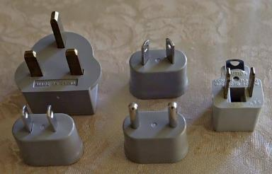
Figure 2. Power Adapters (left) and a U.S. 3-to-2 Wire Power Adapter (right).

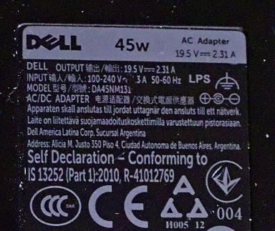
Figure 3. Power Supply Label.

Your cell-phone can comfortably play music for many hours, but if you use it to read an e-book its backlight will deplete the battery on a long trip, leaving you with a dead phone when you arrive. A solution is an external battery pack with USB connectors, and one can also recharge other devices that have USB charging ports; see Figure 4. The one shown has two USB output connectors and is recharged through the mini-USB in the center.

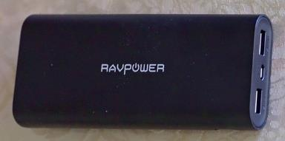
Figure 4. External Battery Pack.

If you have several devices that are recharged through USB cables, you may wish to purchase a power converter with multiple USB outlets, rather than a separate charger for each device. They will charge faster than using a laptop’s USB connectors.

Finally, take spare batteries, as a charge may not last for an entire day. You don’t want to spend a sunny afternoon in Paris looking for that oddball battery your camera uses.

